Three Laws of Robotics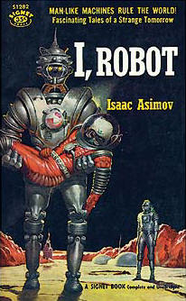

-Isaac Asimov

|  |  |  |
| --- | --- | --- |
| **“** | 1. A robot may not injure a human being or, through inaction, allow a human being to come to harm. 2. A robot must obey any orders given to it by human beings, except where such orders would conflict with the First Law. 3. A robot must protect its own existence as long as such protection does not conflict with the First or Second Law. | **”** |